Pastoral Letter for 26 September 2025
Dear Friends,
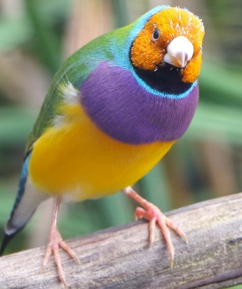
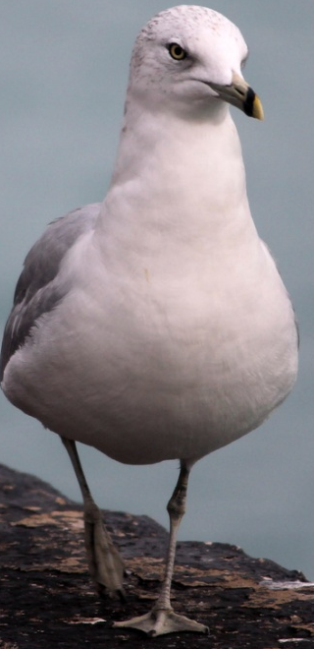
We are almost through the “Season of Creation” and we’ve been watching the antics of birds here in Victoria. My husband has a small table outside that he puts a bowl of food out each day – we’ve seen one seagull actually stand and look inside when the bowl is empty and was knocking with its beak for more. There seems to be an order in the bird kingdom – the crow arrives and other birds scatter, the seagulls come, then maybe some pigeons, and lastly the Indian Mynas, that seem to be the ones at the end of the line. Even among the same species there is a pecking order, and they are soon put in their place if they step out of line, so to speak.

In the current “With Love To The World”, there are some great photos of birds. The photographer is Subramaniam Sukumar and writes “Nature photography has taught me how to slow right down, walk gently, still my body, and work my senses of sight and hearing to find and then capture fleeting images to film. Slowing down also helps me to take stock of the absolute wonder, colour, and intricacy of God’s creation. I hope you find the images invite you to do likewise.”

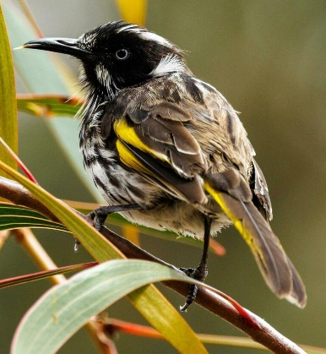
We read in Matthew 6:26 NLT “Look at the birds. They don’t plant or harvest or store food in barns, for your heavenly Father feeds them. And aren’t you far more valuable to him than they are?” As the birds are cared for Jesus reminds us that we are far more valuable to him than they are… what a promise. Have you ever thought of being valuable to God our heavenly Father?
A Prayer for the coming week: Creator God, you have created a world full of wonder and when we look at the birds and see how many different species, colours and shapes and sizes there are, and know that you care for each and everyone of them, we are amazed. Jesus then reminds us that we too are more valuable to you than the birds. Thank you, Lord, that we can be reminded every time we see a little bird, that you care for them, but also, more than that, is that you love and care for us even more, and we are overwhelmed with your great love and care. In Jesus name we pray, Amen

In Christian love and service
Lyn 0412 990 949 or 0499 859 072
His Eye is on the Sparrow
Bing Videos

Why should I feel discouraged?
Why should the shadows come?
Why should my heart be lonely
And long for heav’n and home,
When Jesus is my portion?
My constant Friend is He:
His eye is on the sparrow,
And I know He watches me;
His eye is on the sparrow,
And I know He watches me.
Chorus:
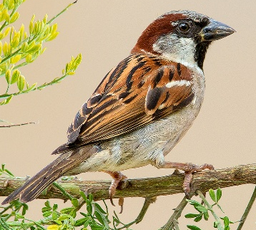
I sing because I’m happy—
I sing because I’m free—
For His eye is on the sparrow,
And I know He watches me.

“Let not your heart be troubled.”
His tender word I hear,
And resting on His goodness,
I lose my doubt and fear.
Though by the path He leadeth,
But one step I may see:
His eye is on the sparrow,
And I know He watches me;
His eye is on the sparrow,
And I know He watches me.
Chorus:

Whenever I am tempted,
Whenever clouds arise,
When songs give place to sighing,
When hope within me dies,
I draw the closer to Him;
From care He sets me free:
His eye is on the sparrow,
And I know He watches me;
His eye is on the sparrow,
And I know He watches me.
Chorus:
All photos have been sourced from the internet.

